Square Foot Seed Planting Template
These templates allow the structure necessary to instruct proper plant spacing. Children take ownership of the task at hand and reduce the amount of clump planting of seeds when they make their own templates. These procedures result in an abundant harvest which is the goal to which all edible gardeners aspire.
Materials:
- Four 12” x 12” pieces of pieces of cardstock or scrapbooking paper (available at most craft stores)
- Ruler
- Pencil/Pen

We will be making templates to plant 1, 4, 9, and 16 seeds per square foot.

How to use your templates:

Use your templates to make more templates!

- Lay your master template over the construction paper and use a wide point child’s
marker to mark the construction paper through the holes of your template.
- Students will create their template by using a chop stick to poke holes through the construction paper at your marks.
- Children can label their templates with seed names or illustrations.
- Using string, divide your space into 1 foot section or grid.
- When planting, the children lay their paper on the soil, make a planting hole through the hole in their template with the chop stick, remove the chop stick and plant the seed.
Suggestion: Have students plant in pairs. One child holds the template while the other plants. Then they switch jobs.
Suggestion: Try to save the children’s templates for re-use throughout the garden year.

Activity adapted from:
Susan Deogracias
Retired elementary teacher; LACO Master Gardener ‘08
Volunteer Garden Club Moderator at Captain Raymond Collins School
Contact info: fourdeos@sbcglobal.net1

This material was produced by institutions that represent SNAP-Ed in California, known as CalFresh, with funding from USDA SNAP-Ed. CalFresh provides assistance to low-income households and can help buy nutritious food for better health. For CalFresh information, call 1-877-847-3663.
- Plants that require 1 square foot of space: 1 seed/plant per square foot.
Example:
Cool-season: Broccoli, cabbage, cauliflower
Warm-season: Cucumber (vine-requires trellis*), eggplant, oregano, peppers, tomato, corn
  - Using your ruler, measure & mark 6” on each side.
  - Connect the marks, across from each other, making a ‘plus sign’ with the center being in the center of the square.
  - Using your pen/pencil/scissors poke a hole directly in the center.

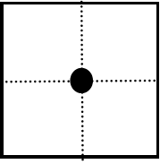
6”

- Plants that require 6 inches of space: 4 seeds/plants per square foot.
Example:
Cool-season: Garlic, lettuce, shallots, chard
Warm-season: Corn, parsley
  - Using your ruler, measure and mark 6” on each side.
  - Connect the marks, across from each other, making a ‘plus sign’ with the center being in the center of the square.
  - Your paper is divided into four quadrants.
  - Find & mark the center of each quadrant.
  - Using pen/pencil/scissors poke a hole in the center of each quadrant.
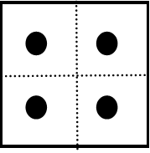
6”

- Plants that require 4 inches of space: 9 seeds/plants per square foot
Example:
Cool-Season: beets, bok choy, onion, peas (require trellis*), spinach
Warm-Season: soybeans, bush beans
  - Measure and mark every 4” around the perimeter of square.
  - Connect marks across from each other.
  - You now have a grid on your paper.
  - Find the center of each square, poke a hole in center.

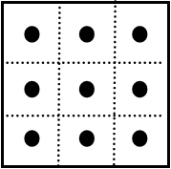
4”

- Plants that require 3 inches of space: 16 seeds/plants per square foot
Example:
Cool-Season: beets, carrots, green onion, radish
Warm-Season:
  - Measure and mark every 3” around the perimeter of square.
  - Connect marks across from each other.
  - You now have a grid on your paper, 16 square in all.
  - Find the center of each square, poke a hole in the center of each square.

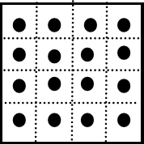
3”

